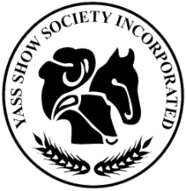
YASS SHOW SOCIETY Inc.

A.B.N. 59 680 416 927

P.O. Box 132 Yass NSW 2582

THIS FORM MAY BE COPIED FOR MULTIPLE ENTRIES

2021 YASS SHOW ENTRY FORM/TAX INVOICE

Please read instructions to exhibitors at the beginning of each section in the schedule.
THE ENTRY FORM MUST BE COMPLETED FOR EACH SECTION
EXCEPT HORSES & LIVESTOCK

Entry Fees and Closing dates – Shown at beginning of each section.

Exhibitor’s Name (Block Letters)

Postal Address

Telephone No.

Email:

Section | Class No. | Particulars of exhibit | Entry  $ | Fees  c.
 |  | Total Entry Fees

I agree to exhibit under the Rules, By-Laws & Regulations of the Society and certify the above entries are true and correct. I understand the judge’s decision is final.

Date ……../……/…… Signature………………………………………………...

